Suppose a contagious disease infected five people. A group of nine friends was then questioned to determine who had had contact with any of the five infected people.
- Explain how you would arrange the data in a matrix form.
- If friends #3 and #6 had contact with infected persons #1, #2, #3, and #5, how would you indicate that in your matrix? Explain.
- Friend #9 had contact with none of the five infected persons, how is it shown on your matrix?
- Infected person #4 had contact with none of the nine friends who were questioned. How is it shown on your matrix?

- In this example I would simply have a chart with the x axis = friend (1-9) and the y-axis infected person (1-5). 1 would indicate contact and 0 would indicate no contact.Such as below:
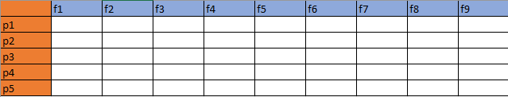
- We fill in the matrix with the correct values and observe what type of row operations we can perform, as so:
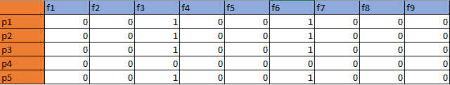
- From the matrix you can see f9 has a value of 0 for p1,p2,p3,p4, and p5.
- From the matrix p4 has no value for f1- f9.

